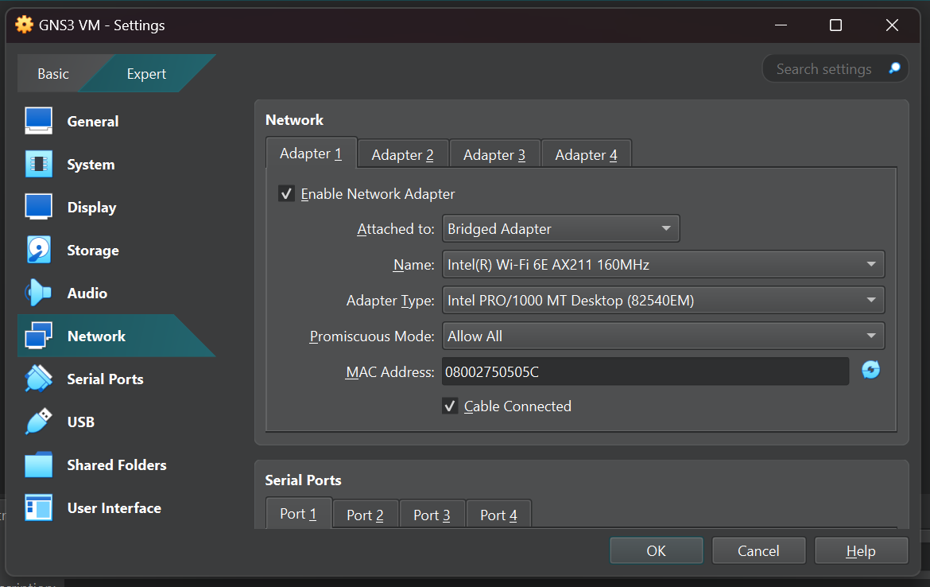

Gns VM network setting

Kali linux (Real Node for Ansible) network setting

figure: R1 configured to get its IP address via DHCP and is accessible from the Ansible (Kali) VM using SSH.

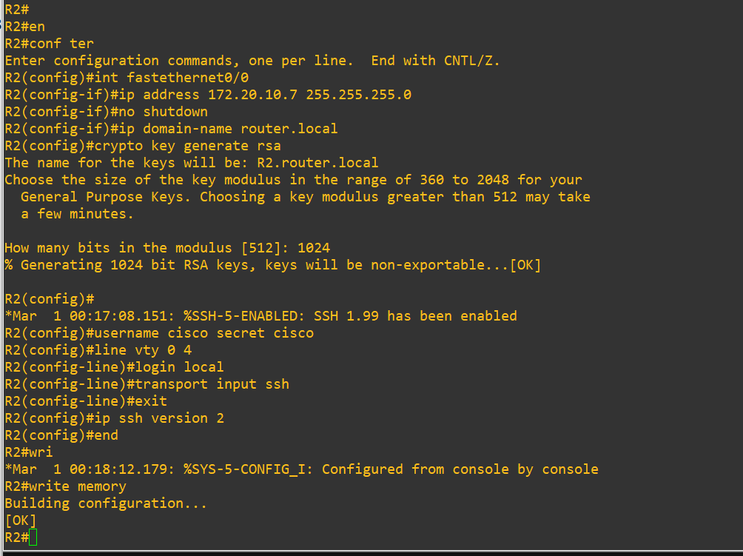

Figure setting up static ip and ssh in router 2 from console

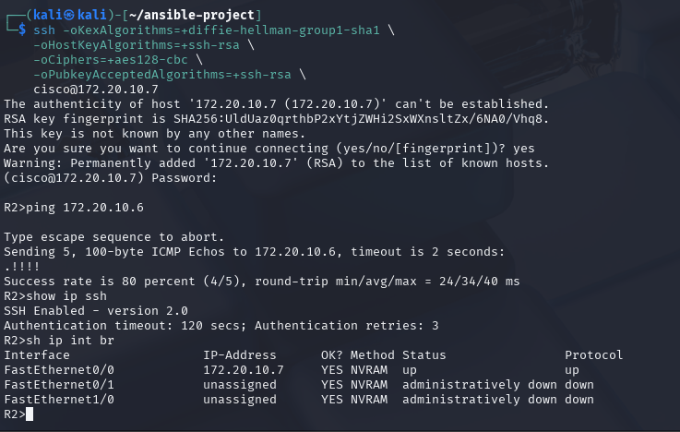

Ssh configuration in r2 complete

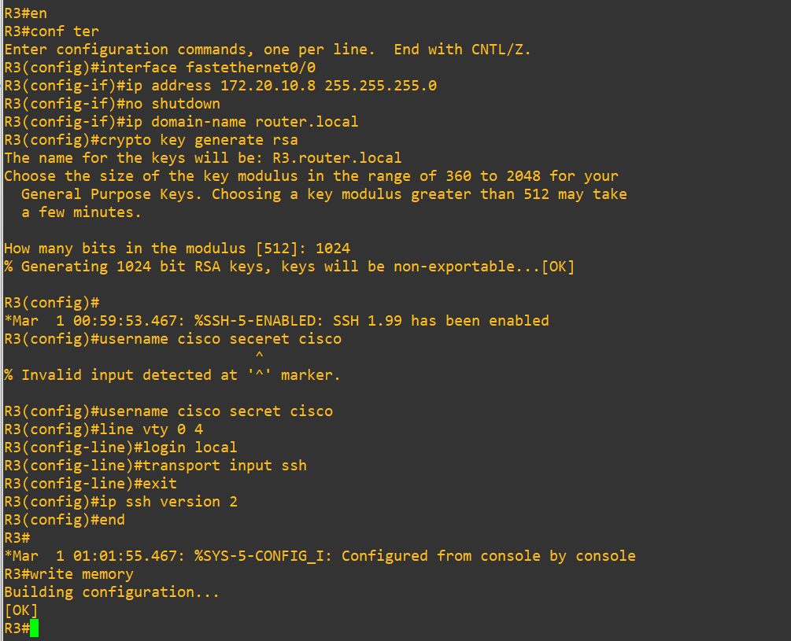

Figure setting up static ip and ssh in router 3 from console

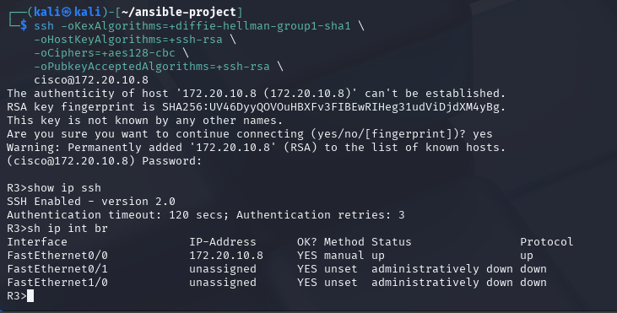

Ssh configuration in r3 complete

Automate hostname change of all routers using ansible

Adding ospf routing protocol to all routers in topology using ansible

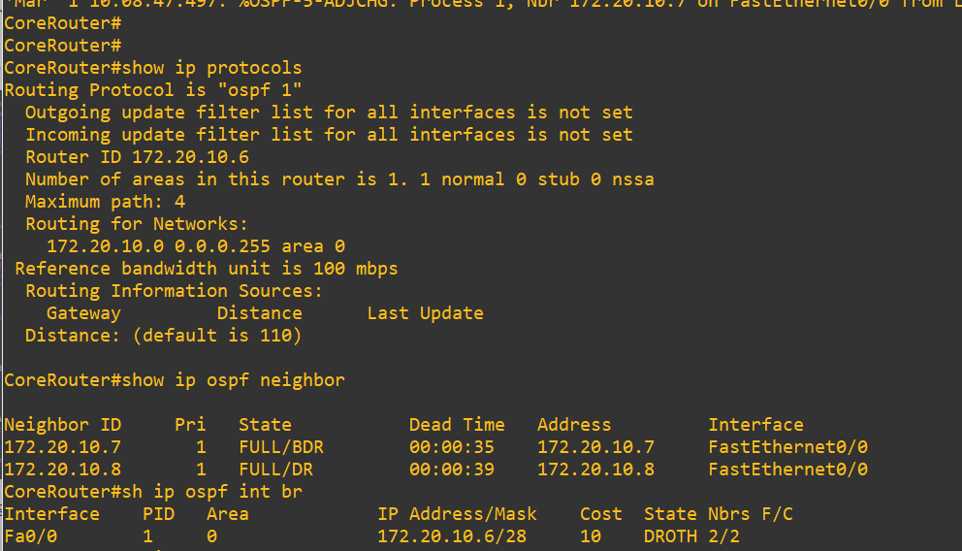

Output after adding ospf routing protocol.

Remove routing protocols from all router using ansible

Outputs on console after removing ospf routing protocol